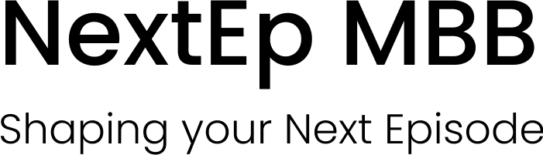
Curriculum Vitae template
BEFORE STARTING
First of all, thank you for choosing our materials as part of your preparation.
It means a great deal that you decided to trust these materials.
If you want to keep making progress beyond this template, you can sign up to receive short, practical FlashTips every day.
Each tip covers a key element of the consulting application process — from mental math to case structuring, fit questions, and interview techniques.
It’s a simple way to stay consistent and strengthen your preparation step by step.
Sign up here: https://nextepmbb.beehiiv.com/subscribe

INTRODUCTION

This CV template is designed to help you create a consulting resume that meets the standards of top firms. It provides a ready-to-use format — with font, size, spacing, and layout already defined — so you can focus on the content rather than the design.

With this structure, you will learn how to frame your achievements in an output-driven way, highlighting leadership, analytical skills, and measurable results.

The goal is simple: a CV that passes the screening filter and captures the recruiter’s attention.

WANT TO TAKE YOUR PREPARATION FURTHER?

Visit our full guide on the NextEp website, where you’ll find detailed advice, examples, and additional resources to strengthen your consulting CV.

COMPLETE NAME
[…]@gmail.com / +34 [[…]

SUMMARY
As a final-year student of Industrial Engineering at […], I am pursuing a career in a top-tier firm to have the opportunity to work in a dynamic environment that requires a high level of determination. Passionate about creating value for companies that are making the world a better place. I am self-managed but a team player and a hard worker, always looking to go the extra mile.

EDUCATION

[…] Madrid, Spain
Bachelor’s Degree in Industrial Engineering September 20[…] – Present
- Annual course completion – Currently enrolled in the fourth year
- […] oriented track
- Advanced extracurricular course in […]
- Associations: Active Member of […]

Courses at […] New York and Toronto, USA
Immersion in American Education 20[…] & 20[…]
- […] College 3-month program. English, entrepreneurship, and leadership
- University of […] 3-month summer program. English & Sport

[…] Barcelona, Spain
High School Education September 20[…] – June 20[…]
- Technological High School Diploma – Final Grade 9.6/10
- High School Graduation Project – CUM LAUDE 10/10

[…] Barcelona, Spain
University Entrance Exam July 20[…]
- Final Grade 9.2/10

PROFESIONAL EXPERIENCE
[…] (Spanish company dedicated to the development of real estate promotions) Barcelona, Spain
Summer Intern Summer of 20[…]
- Provide support and assistance to the engineering team, including fieldwork and site visits.
- Perform auxiliary tasks for […].

[…] Barcelona, Spain Support assistant September 20[…] – June 20[…]
- […]
- […]

LANGUAGES
SPANISH: Native / ENGLISH: High – Intermediate / FRENCH: Intermediate

VOLUNTEER EXPERIENCE
- Regular attendance at charitable actions at […]
- Assistance in event coordination for […]
- Regular contributor to […]

OTHER ACTIVITIES
- Instructor at […]
- Advanced User of Matlab, Excel, GAMS, AutoCad, Programing language C++
- Sport: Captain of […]
- Other areas of interest: traveling, embracing new cultures, a bias for action, family & friends first.

